T-Shaped Polyhedron
# Source: AI Source: Provided by: [Data Path: Persons Table -> ID Column: 1, Name_En Column: Motasem Essam] -> From: [ChatGPT] on [7/25/2026]
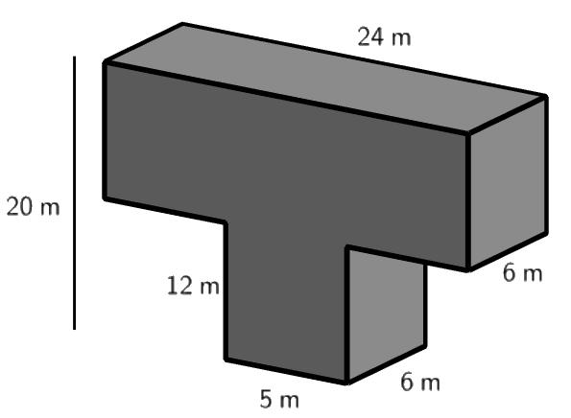
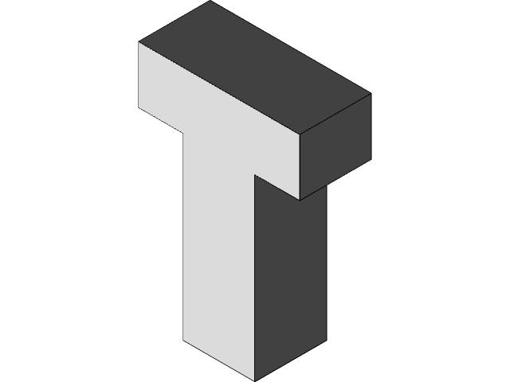
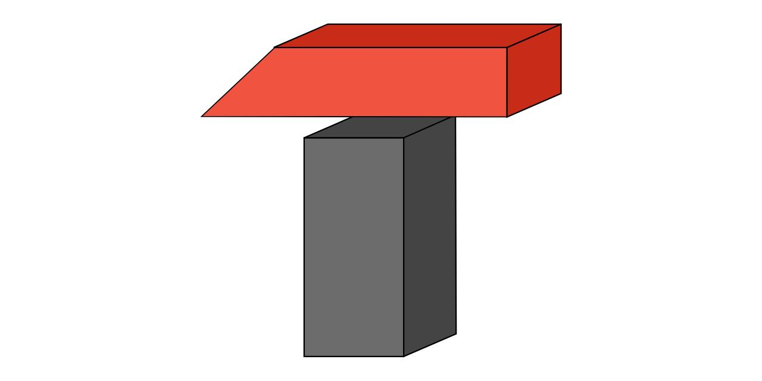

Definition
# Source: AI Source: Provided by: [Data Path: Persons Table -> ID Column: 1, Name_En Column: Motasem Essam] -> From: [ChatGPT] on [7/25/2026]
A T-shaped polyhedron is a three-dimensional polyhedron whose overall form resembles the letter T when viewed from a particular direction. A common example is a T-shaped prism, formed by extending a T-shaped polygon into the third dimension.
When the T-shaped base has inward corners, the resulting prism is a concave polyhedron. Its boundary consists of flat polygonal faces joined along straight edges.
The term describes a family of geometric solids rather than one unique polyhedron. Its dimensions and numbers of faces, edges, and vertices depend on the construction.

Simple Definition
# Source: AI Source: Provided by: [Data Path: Persons Table -> ID Column: 1, Name_En Column: Motasem Essam] -> From: [ChatGPT] on [7/25/2026]
A T-shaped polyhedron is a solid with flat polygonal faces that resembles the letter T and typically has inward corners.

Key Characteristics
# Source: AI Source: Provided by: [Data Path: Persons Table -> ID Column: 1, Name_En Column: Motasem Essam] -> From: [ChatGPT] on [7/25/2026]
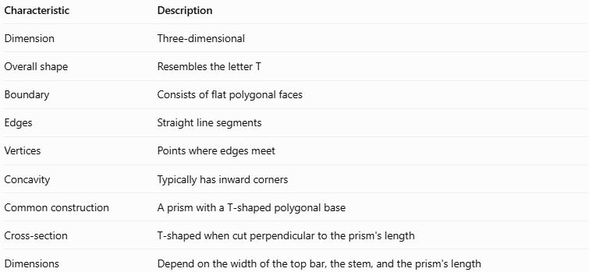
Characteristic | Description
Dimension | Three-dimensional
Overall shape | Resembles the letter T
Boundary | Consists of flat polygonal faces
Edges | Straight line segments
Vertices | Points where edges meet
Concavity | Typically has inward corners
Common construction | A prism with a T-shaped polygonal base
Cross-section | T-shaped when cut perpendicular to the prism's length
Dimensions | Depend on the width of the top bar, the stem, and the prism's length

Geometric Representation
# Source: AI Source: Provided by: [Data Path: Persons Table -> ID Column: 1, Name_En Column: Motasem Essam] -> From: [ChatGPT] on [7/25/2026]
A common T-shaped prism can be constructed from a T-shaped polygon consisting of four equal squares: three squares forming the top bar and one square centered beneath them.
Its main components are:
- T-shaped bases: Two congruent, parallel T-shaped polygons.
- Lateral faces: Rectangular faces connecting corresponding edges of the bases in a right prism.
- Lateral edges: Edges connecting corresponding vertices of the two bases.
- Inner corners: Recessed corners on either side of the stem.
- Top bar: The horizontal section of the T.
- Stem: The vertical section extending from the center of the top bar.

Mathematical Properties and Formulas
# Source: AI Source: Provided by: [Data Path: Persons Table -> ID Column: 1, Name_En Column: Motasem Essam] -> From: [ChatGPT] on [7/25/2026]
Consider a right T-shaped prism whose base consists of four equal squares arranged in a T shape.
Let:
- $a$ = side length of each square
- $h$ = length of the prism
- $B$ = area of the T-shaped base
- $P$ = perimeter of the T-shaped base

Base Area
# Source: AI Source: Provided by: [Data Path: Persons Table -> ID Column: 1, Name_En Column: Motasem Essam] -> From: [ChatGPT] on [7/25/2026]
The base contains four equal squares:
$$\boxed{B=4a^{2}}$$

Base Perimeter
# Source: AI Source: Provided by: [Data Path: Persons Table -> ID Column: 1, Name_En Column: Motasem Essam] -> From: [ChatGPT] on [7/25/2026]
The T-shaped base has a perimeter of ten square-side lengths:
$$\boxed{P=10a}$$

Volume
# Source: AI Source: Provided by: [Data Path: Persons Table -> ID Column: 1, Name_En Column: Motasem Essam] -> From: [ChatGPT] on [7/25/2026]
The volume of a prism is its base area multiplied by its length:
$$V=Bh$$
Therefore,
$$\boxed{V=4a^{2}h}$$

Lateral Surface Area
# Source: AI Source: Provided by: [Data Path: Persons Table -> ID Column: 1, Name_En Column: Motasem Essam] -> From: [ChatGPT] on [7/25/2026]
For a right prism:
$$A_{L}=Ph$$
Therefore,
$$\boxed{A_{L}=10ah}$$

Total Surface Area
# Source: AI Source: Provided by: [Data Path: Persons Table -> ID Column: 1, Name_En Column: Motasem Essam] -> From: [ChatGPT] on [7/25/2026]
$$A_{T}=2B+Ph$$
Substituting the base area and perimeter:
$$\boxed{A_{T}=8a^{2}+10ah}$$

Number of Faces, Edges, and Vertices
# Source: AI Source: Provided by: [Data Path: Persons Table -> ID Column: 1, Name_En Column: Motasem Essam] -> From: [ChatGPT] on [7/25/2026]
The standard T-shaped base in this example has eight sides. For a prism with an $n$-sided polygonal base:
$$F=n+2, E=3n, V_{e}=2n$$
For $n=8$:
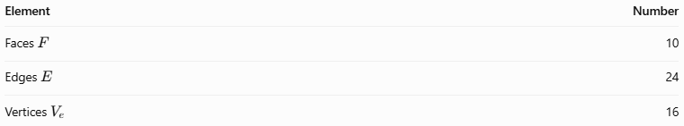
Element | Number
Faces $F$ | 10
Edges $E$ | 24
Vertices $V_{e}$ | 16
Euler's formula confirms the counts:
$$V_{e}-E+F=16-24+10=2$$
These values apply to this particular T-shaped prism.

Worked Examples
# Source: AI Source: Provided by: [Data Path: Persons Table -> ID Column: 1, Name_En Column: Motasem Essam] -> From: [ChatGPT] on [7/25/2026]
Example 1: Calculating the Volume
A T-shaped prism has a base formed from four equal squares, each with a side length of $3\text{ cm}$. The prism's length is $5\text{ cm}$.
Step 1 — Calculate the base area.
$$B=4a^{2}=4\left(3^{2}\right)=36{\text{ cm}}^{2}$$
Step 2 — Calculate the volume.
$$V=Bh=36×5$$
$$\boxed{V=180{\text{ cm}}^{3}}$$
Example 2: Calculating the Total Surface Area
Using the same prism, $a=3\text{ cm}$ and $h=5\text{ cm}$.
Step 1 — Calculate the base perimeter.
$$P=10a=10\left(3\right)=30\text{ cm}$$
Step 2 — Calculate the lateral surface area.
$$A_{L}=Ph=30×5=150{\text{ cm}}^{2}$$
Step 3 — Calculate the total surface area.
$$A_{T}=2B+A_{L}$$
$$A_{T}=2\left(36\right)+150$$
$$\boxed{A_{T}=222{\text{ cm}}^{2}}$$

Comparison with Related Concepts
# Source: AI Source: Provided by: [Data Path: Persons Table -> ID Column: 1, Name_En Column: Motasem Essam] -> From: [ChatGPT] on [7/25/2026]
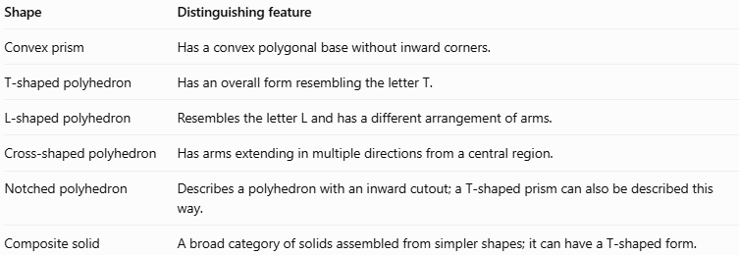
Shape | Distinguishing feature
Convex prism | Has a convex polygonal base without inward corners.
T-shaped polyhedron | Has an overall form resembling the letter T.
L-shaped polyhedron | Resembles the letter L and has a different arrangement of arms.
Cross-shaped polyhedron | Has arms extending in multiple directions from a central region.
Notched polyhedron | Describes a polyhedron with an inward cutout; a T-shaped prism can also be described this way.
Composite solid | A broad category of solids assembled from simpler shapes; it can have a T-shaped form.

Constructing T-Shaped Polyhedron in Solid Geometry

Instruments Used
# Source: AI Source: Provided by: [Data Path: Persons Table -> ID Column: 1, Name_En Column: Motasem Essam] -> From: [ChatGPT] on [7/25/2026]
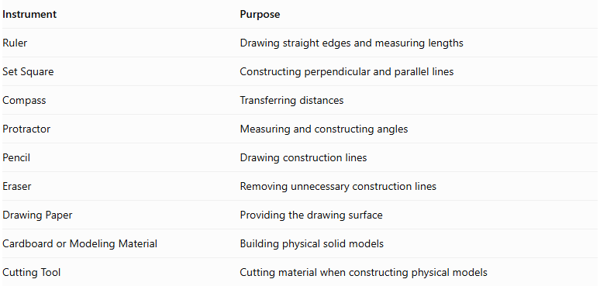
Instrument | Purpose
Ruler | Drawing straight edges and measuring lengths
Set Square | Constructing perpendicular and parallel lines
Compass | Transferring distances
Protractor | Measuring and constructing angles
Pencil | Drawing construction lines
Eraser | Removing unnecessary construction lines
Drawing Paper | Providing the drawing surface
Cardboard or Modeling Material | Building physical solid models
Cutting Tool | Cutting material when constructing physical models

Construction Procedures

A. Addition-Based Construction
# Source: AI Source: Provided by: [Data Path: Persons Table -> ID Column: 1, Name_En Column: Motasem Essam] -> From: [ChatGPT] on [7/25/2026]
This method forms a T-shaped polyhedron by joining rectangular prisms.
- Determine the dimensions of the main horizontal component and the connecting component.
- Draw the main rectangular prism using an appropriate pictorial representation.
- Draw the connecting rectangular prism perpendicular to the main component.
- Position the connecting component at the center or selected offset position.
- Join the two components through an appropriate shared rectangular face or connecting region.
- Remove or visually suppress internal boundaries that are not part of the external surface.
- Draw the visible external and recessed faces.
- Distinguish visible edges from hidden edges.
- Check that the resulting solid has a continuous closed surface.

B. Subtraction-Based Construction
# Source: AI Source: Provided by: [Data Path: Persons Table -> ID Column: 1, Name_En Column: Motasem Essam] -> From: [ChatGPT] on [7/25/2026]
This method creates a T-shaped polyhedron by removing selected portions from a larger rectangular prism.
- Draw a rectangular prism representing the original solid.
- Identify the rectangular portions to be removed.
- Mark the boundaries of the removed portions.
- Construct the cutting boundaries on the relevant faces.
- Remove or visually suppress the selected portions.
- Draw the newly exposed inner faces.
- Connect all remaining face boundaries.
- Refine the visible and hidden edges.
- Check that the resulting solid has a T-shaped appearance.

C. Cross-Section-Based Construction
# Source: AI Source: Provided by: [Data Path: Persons Table -> ID Column: 1, Name_En Column: Motasem Essam] -> From: [ChatGPT] on [7/25/2026]
- Draw a T-shaped polygon representing the cross-section.
- Mark the dimensions of the horizontal bar.
- Mark the dimensions and position of the vertical stem.
- Draw a second congruent T-shaped polygon at the required depth.
- Connect corresponding vertices of the two polygons.
- Complete the rectangular lateral faces.
- Darken the visible edges and distinguish hidden edges.

D. Face-Based Construction
# Source: AI Source: Provided by: [Data Path: Persons Table -> ID Column: 1, Name_En Column: Motasem Essam] -> From: [ChatGPT] on [7/25/2026]
- Identify the external rectangular faces and recessed faces.
- Draw the main horizontal surfaces.
- Construct the perpendicular connecting surfaces.
- Draw the inner corner surfaces beside the connecting component.
- Connect adjacent faces using shared edges.
- Complete the external boundaries of the solid.
- Check that all faces form a closed polyhedron.

E. Net-Based Construction
# Source: AI Source: Provided by: [Data Path: Persons Table -> ID Column: 1, Name_En Column: Motasem Essam] -> From: [ChatGPT] on [7/25/2026]
- Determine the dimensions of all external and recessed faces.
- Draw a connected net containing the two T-shaped end faces and the rectangular lateral faces.
- Arrange the faces so their shared edges correspond correctly.
- Add tabs if the net will be used for physical assembly.
- Cut out the net.
- Fold along the shared edges.
- Join the corresponding edges to form the T-shaped polyhedron.
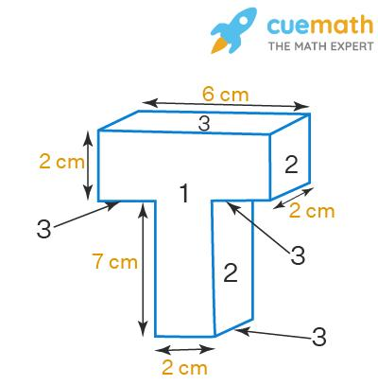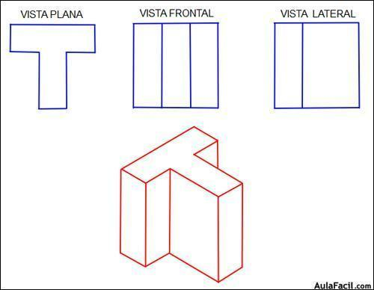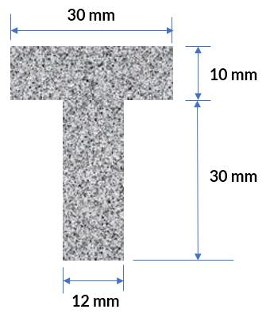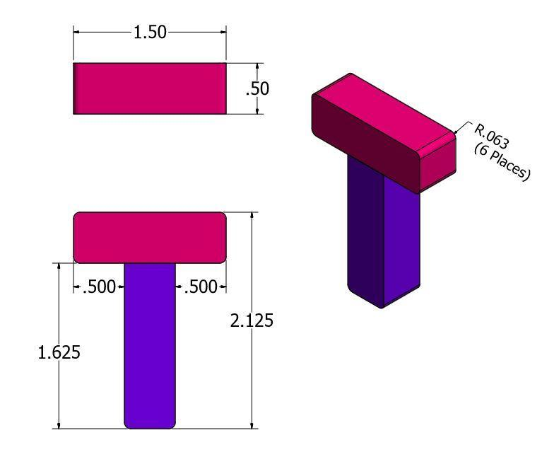

Applications
# Source: AI Source: Provided by: [Data Path: Persons Table -> ID Column: 1, Name_En Column: Motasem Essam] -> From: [ChatGPT] on [7/25/2026]
- Architecture: Modeling T-shaped buildings and floor plans.
- Construction: Calculating the volume of T-shaped concrete sections.
- Engineering: Designing beams, supports, and structural components.
- Manufacturing: Modeling parts with T-shaped cross-sections.
- Computer graphics: Creating three-dimensional objects with concave boundaries.
- Geometry education: Practicing area, perimeter, surface area, and volume.

Key Points
# Source: AI Source: Provided by: [Data Path: Persons Table -> ID Column: 1, Name_En Column: Motasem Essam] -> From: [ChatGPT] on [7/25/2026]
- A T-shaped polyhedron resembles the letter T when viewed from a suitable direction.
- A common example is a prism with a concave T-shaped polygonal base.
- The example base made from four equal squares has eight sides.
- Its right prism has 10 faces, 24 edges, and 16 vertices.
- Its volume is $V=Bh$.
- Its total surface area is $A_{T}=2B+Ph$.
- The exact properties depend on the dimensions and construction of the solid.

Conclusion
# Source: AI Source: Provided by: [Data Path: Persons Table -> ID Column: 1, Name_En Column: Motasem Essam] -> From: [ChatGPT] on [7/25/2026]
A T-shaped polyhedron is a three-dimensional solid characterized by its T-like overall form. A T-shaped prism is a common example, with a concave polygonal base and flat lateral faces. It provides a practical way to study concave polyhedra and apply geometric formulas for volume, surface area, and Euler's formula.

